Excerpted from “Applied Analytics Using SAS Enterprise Miner: Course Notes”

Cluster Analysis
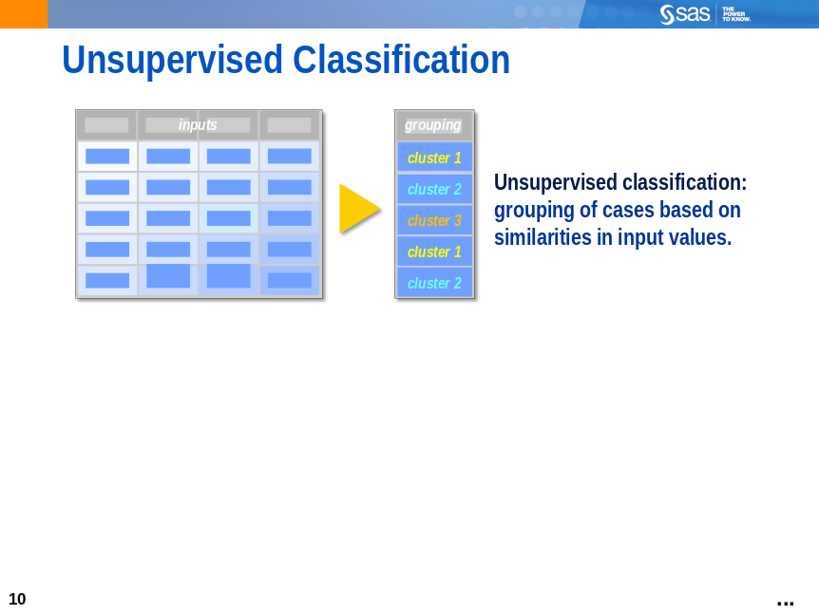
Unsupervised classification (also known as clustering and segmenting) attempts to group training data set cases based on similarities in input variables. It is a data reduction method because an entire training data set can be represented by a small number of clusters. The groupings are known as clusters or segments, and they can be applied to other data sets to classify new cases. It is distinguished from supervised classification (also known as predictive modeling), which is discussed in previous chapters.
The purpose of clustering is often description. For example, segmenting existing customers into groups and associating a distinct profile with each group might help future marketing strategies. However, there is no guarantee that the resulting clusters will be meaningful or useful.
Unsupervised classification is also useful as a step in predictive modeling. For example, customers can be clustered into homogenous groups based on sales of different items. Then a model can be built to predict the cluster membership based on more easily obtained input variables.
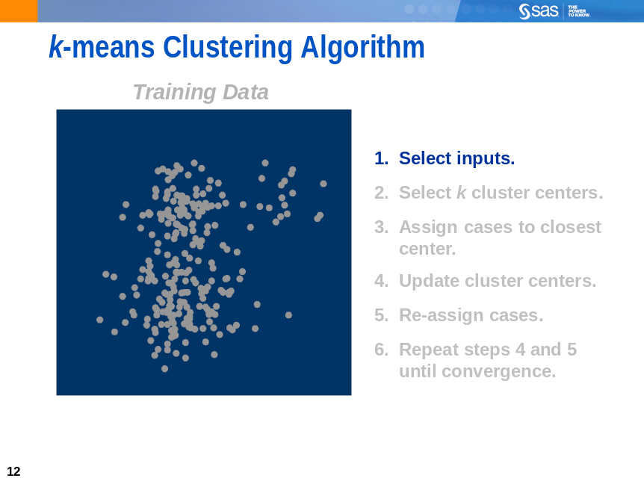
One of the most commonly used methods for clustering is the k-means algorithm. It is a straightforward algorithm that scales well to large data sets and is, therefore, the primary tool for clustering in SAS Enterprise Miner.
While often overlooked as an important part of a clustering process, the first step in using the k-means algorithm is to choose a set of inputs. In general, you should seek inputs that have the following attributes:
- are meaningful to the analysis objective
- are relatively independent
- are limited in number
- have a measurement level of Interval
- have low kurtosis and skewness statistics (at least in the training data)
Choosing meaningful inputs is clearly important for interpretation and explanation of the generated clusters. Independence and limited input count make the resulting clusters more stable. (Small perturbations of training data usually do not result in large changes to the generated clusters.) An interval measurement level is recommended for k-means to produce non-trivial clusters. Low kurtosis and skewness statistics on the inputs avoid creating single-case outlier clusters.
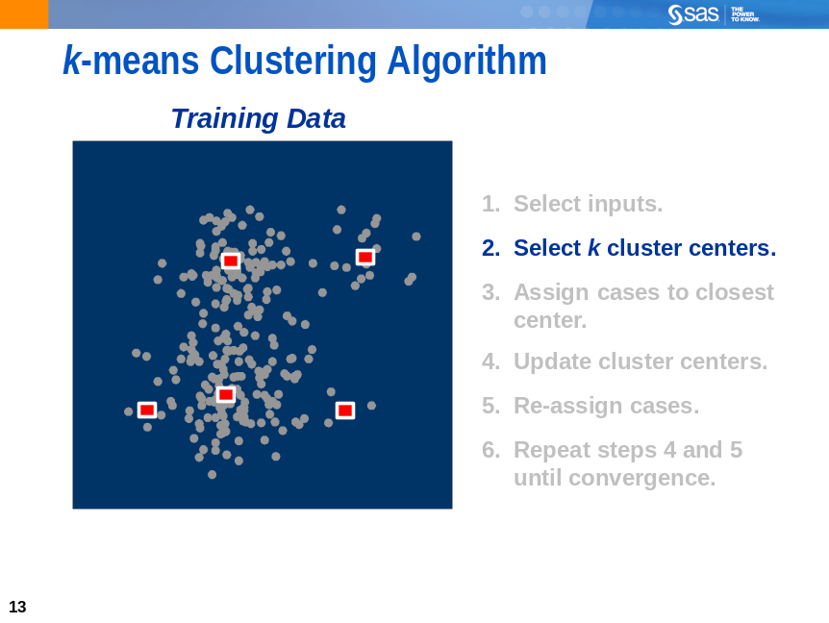
The next step in the k-means algorithm is to choose a value for k, the number of cluster centers.
SAS Enterprise Miner features an automatic way to do this, assuming that the data has k distinct concentrations of cases. If this is not the case, you should choose k to be consistent with your
analytic objectives.
With k selected, the k-means algorithm chooses cases to represent the initial cluster centers (also named seeds).
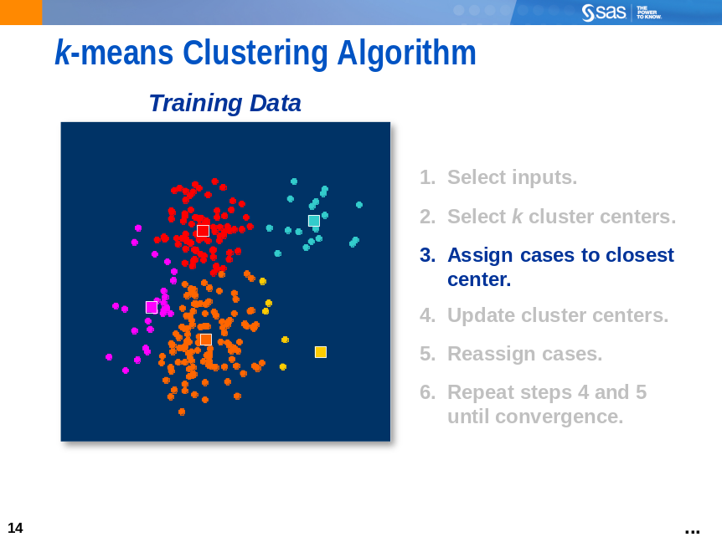
The Euclidean distance from each case in the training data to each cluster center is calculated. Cases are assigned to the closest cluster center.
 Because the distance metric is Euclidean, it is important for the inputs to have compatible measurement scales. Unexpected results can occur if one input’s measurement scale differs greatly from the others.
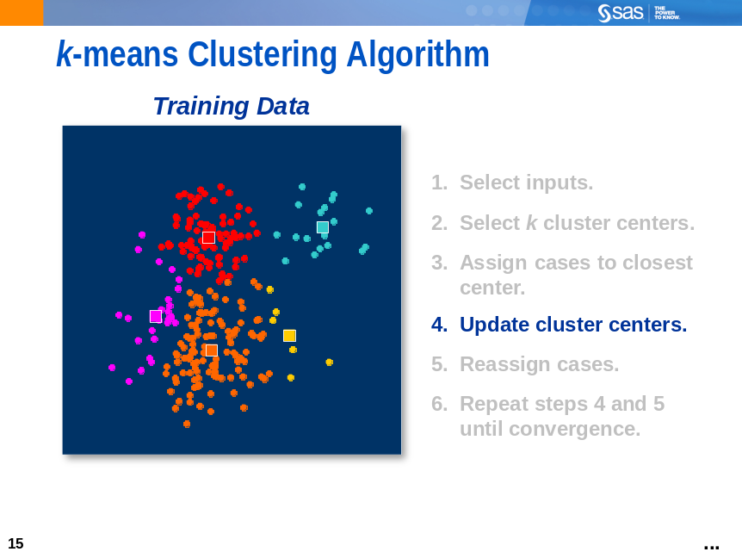
The cluster centers are updated to equal the average of the cases assigned to the cluster
in the previous step.
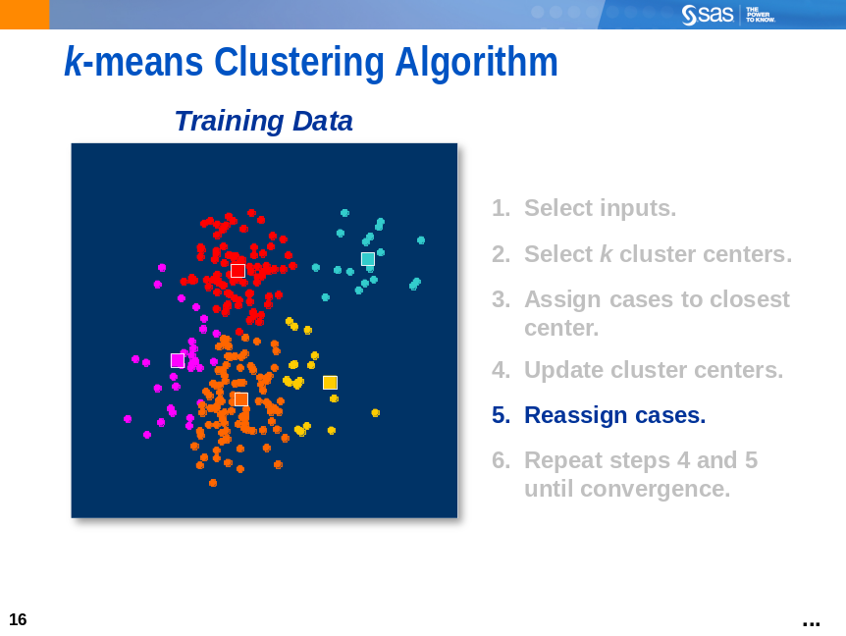
Cases are reassigned to the closest cluster center.
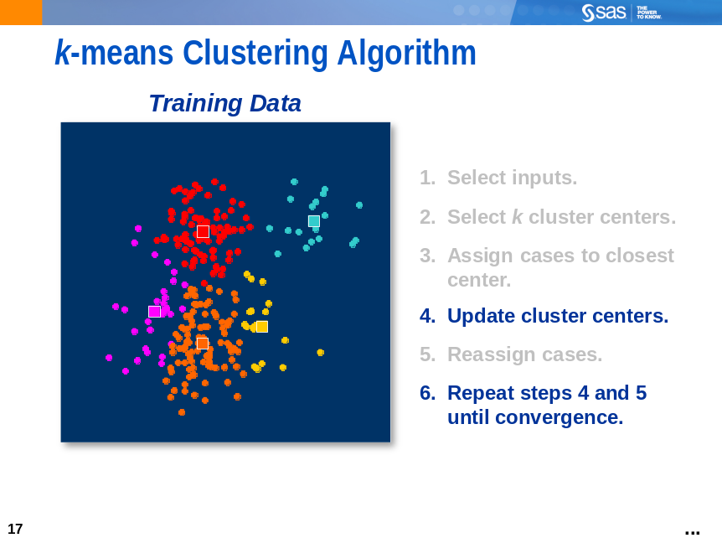
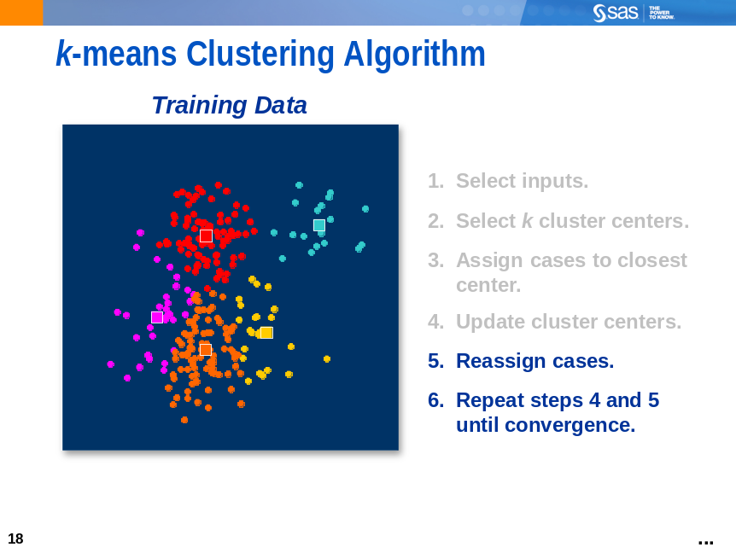
The update and reassign steps are repeated until the process converges.
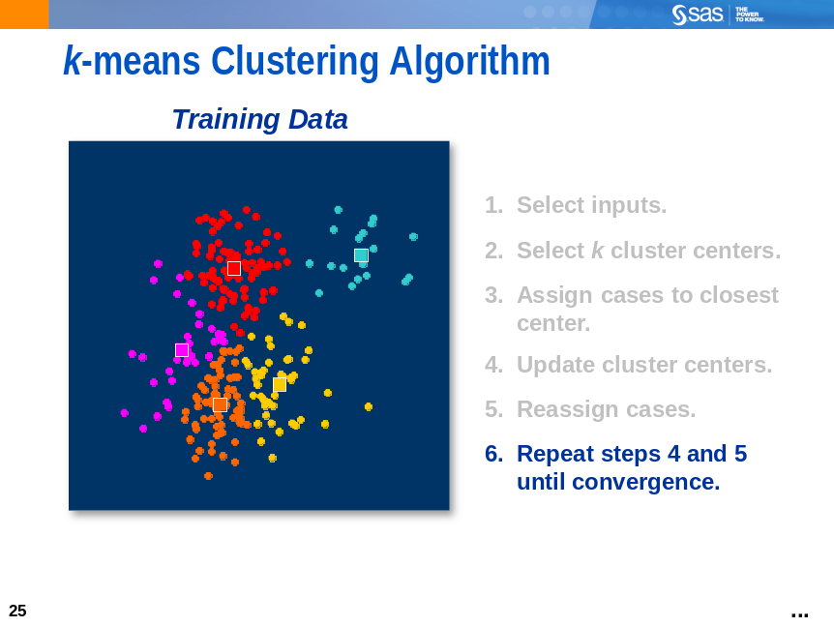
On convergence, final cluster assignments are made. Each case is assigned to a unique segment.
The segment definitions can be stored and applied to new cases outside of the training data.
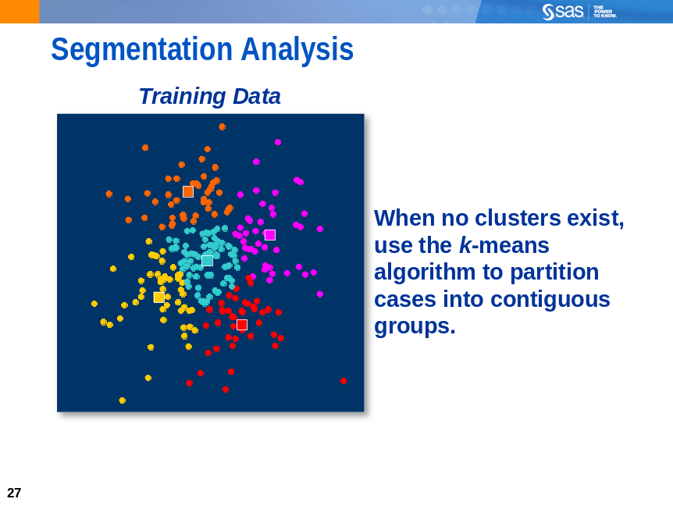
While they are often used synonymously, a segmentation analysis is distinct from a traditional cluster analysis. A cluster analysis is geared toward identifying distinct concentrations of cases in a data set. When no distinct concentrations exist, the best you can do is a segmentation analysis – that is, algorithmically partitioning the input space into contiguous groups of cases.

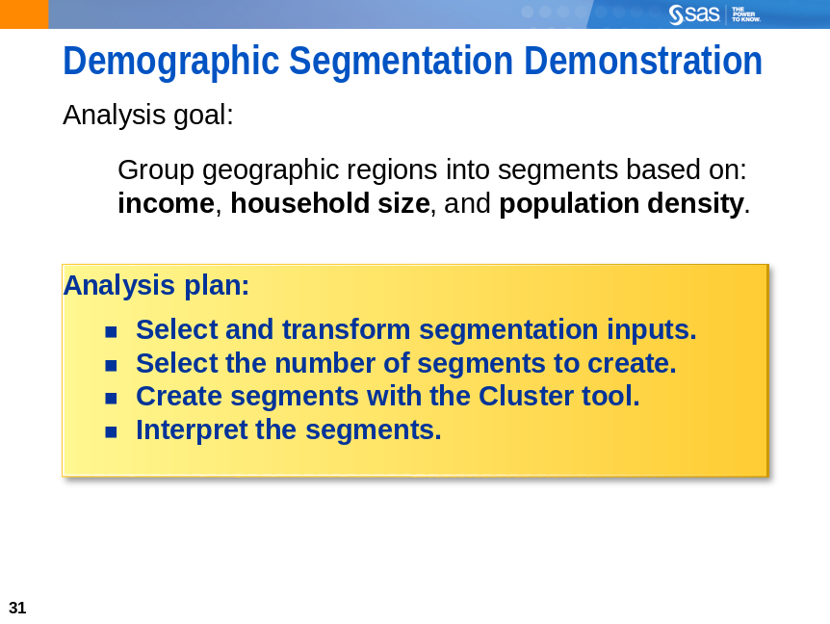
The following demonstration illustrates the use of clustering tools. The goal of the analysis is to group people in the United States into distinct subsets based on urbanization, household size, and income factors. These factors are common to commercial lifestyle and life-stage segmentation products.
(For examples, see www.claritas.com or www.spectramarketing.com.)

Segmenting Census Data

This demonstration introduces SAS Enterprise Miner tools and techniques for cluster and segmentation analysis. There are five parts:
- define the diagram and data source
- explore and filter the training data
- integrate the Cluster tool into the process flow and select the number of segments to create
- run a segmentation analysis
- use the Segment Profile tool to interpret the analysis results

Diagram Definition
Use the following steps to define the diagram for the segmentation analysis.
- Right-click Diagrams in the Project panel and select Create Diagram. The Create New Diagram window appears and requests a diagram name.
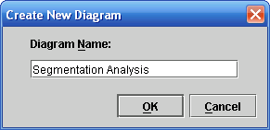
- Type Segmentation Analysis in the Diagram Name field and select OK. SAS Enterprise Miner creates an analysis workspace window named Segmentation Analysis.
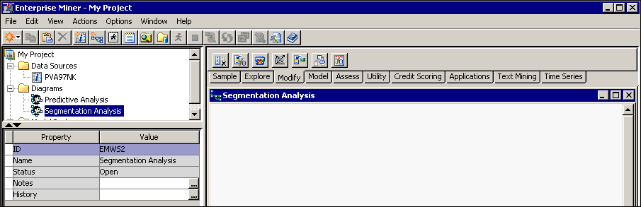
You use the Segmentation Analysis window to create process flow diagrams.

Data Source Definition
Follow these steps to create the segmentation analysis data source.
- Right-click Data Sources in the Project panel and select Create Data Source. The Data Source Wizard appears.
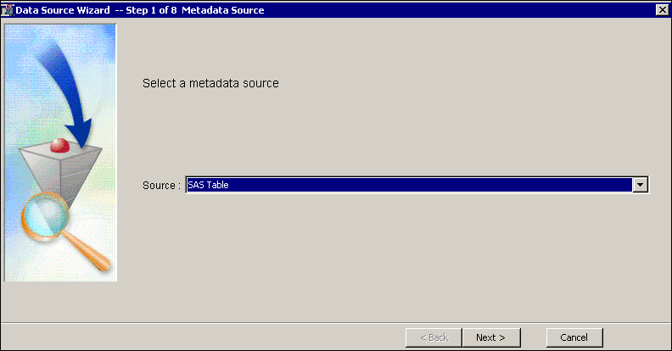
The Data Source Wizard guides you through a process to create a SAS Enterprise Miner data source.
- Select Next to use a SAS table as the source for the metadata. (This is the usual choice.)
In this step, select the SAS table that you want to make available to SAS Enterprise Miner. You can either type the library name and SAS table name as libname.table-name or select the SAS table from a list.
- Select Browse to choose a SAS table from the libraries visible to the SAS Foundation server.
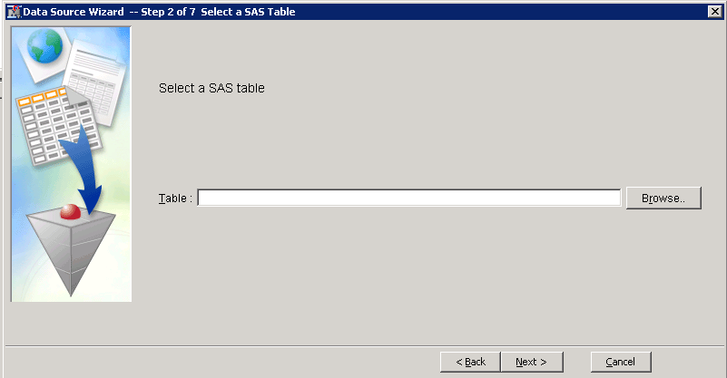
The Select a SAS Table dialog box appears.
One of the libraries listed is named AAEM, which is the library name defined in Chapter 2.
Select Aaem and the Census2000 SAS table.
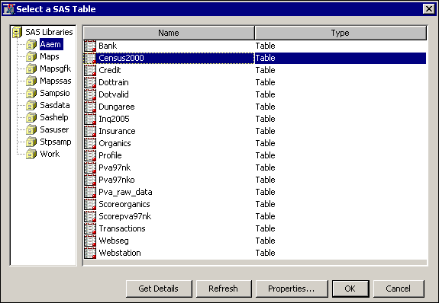
The Census2000 data is a postal code-level summary of the entire 2000 United States Census.
It features seven variables:
ID postal code of the region
LOCX region longitude
LOCY region latitude
MEANHHSZ average household size in the region
MEDHHINC median household income in the region
REGDENS region population density percentile (1=lowest density, 100=highest density)
REGPOP number of people in the region
The data is suited for creation of life-stage, lifestyle segments using SAS Enterprise Miner’s pattern discovery tools.
- Select OK.
The Select a SAS Table dialog box closes and the selected table is entered in the Table field.
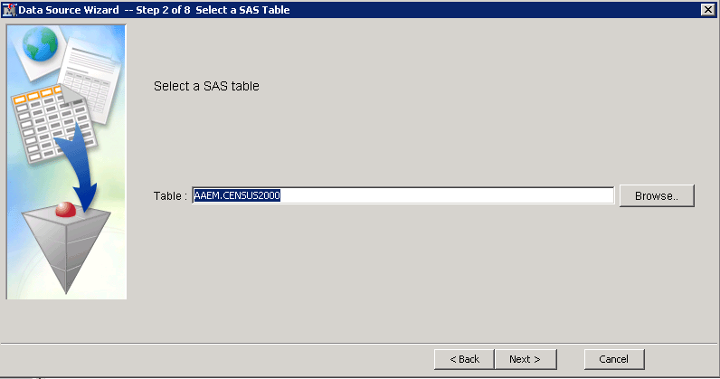
- Select Next in two consecutive windows.

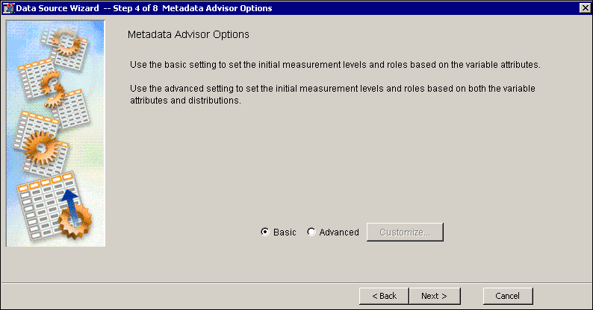
The Data Source Wizard starts the metadata definition process. SAS Enterprise Miner assigns initial values to the metadata based on characteristics of the selected SAS table. The Basic setting assigns initial values to the metadata based on variable attributes such as the variable name, data type, and assigned SAS format. The Advanced setting also includes information about the distribution of the variable to assign the initial metadata values.
- Select Next to use the Basic setting.
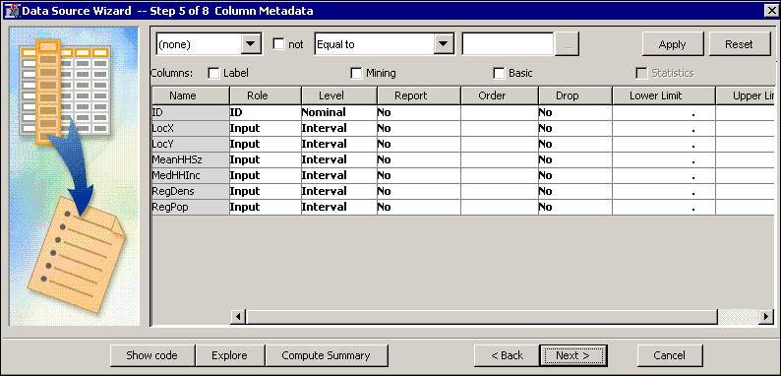
The Data Source Wizard enables you to specify the role and level for each variable in the selected SAS table. A default role is assigned based on the name of a variable. For example, the variable ID was given the role ID based on its name. When a variable does not have a name corresponding to one of the possible variable roles, it will, using the Basic setting, be given the default role of Input. An input variable is used for various types of analysis to describe a characteristic, measurement, or attribute of a record, or case, in a SAS table.
The metadata settings are correct for the upcoming analysis.
- Select Next until you reach Step 7. This is the second-to-last step in the Data Source Wizard.
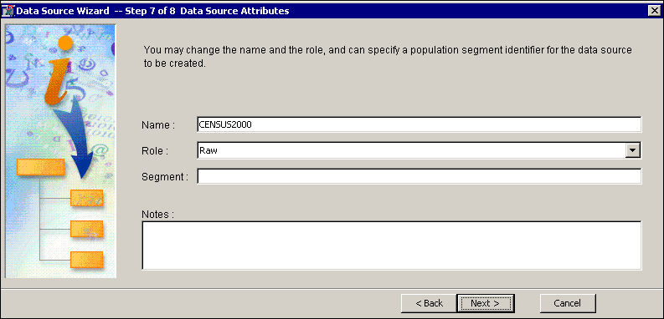
The Data Source Wizard enables you to set a role for the selected SAS table and provide descriptive comments about the data source definition.
For the impending analysis, a table role of Raw is acceptable.
- Select Finish to complete the data source definition. The CENSUS2000 table is added to the
Data Sources entry in the Project panel.

Exploring and Filtering Analysis Data

A worthwhile next step in the process of defining a data source is to explore and validate its contents.
By assaying the prepared data, you substantially reduce the chances of erroneous results in your analysis, and you can gain insights graphically into associations between variables.

Data Source Exploration
- Right-click the CENSUS2000 data source and select Edit Variables from the shortcut menu.
The Variables - CENSUS2000 dialog box appears.
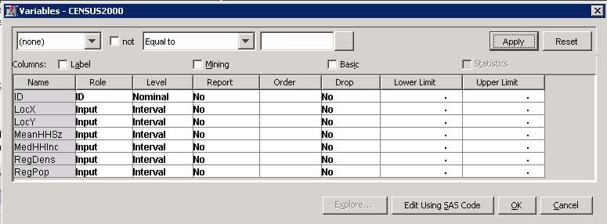
- Examine histograms for the available variables.
- Select all listed inputs by dragging the cursor across all of the input names or by holding down the CTRL key and typing A.
- Select Explore. The Explore window appears, and this time displays histograms for all of the variables in the CENSUS2000 data source.
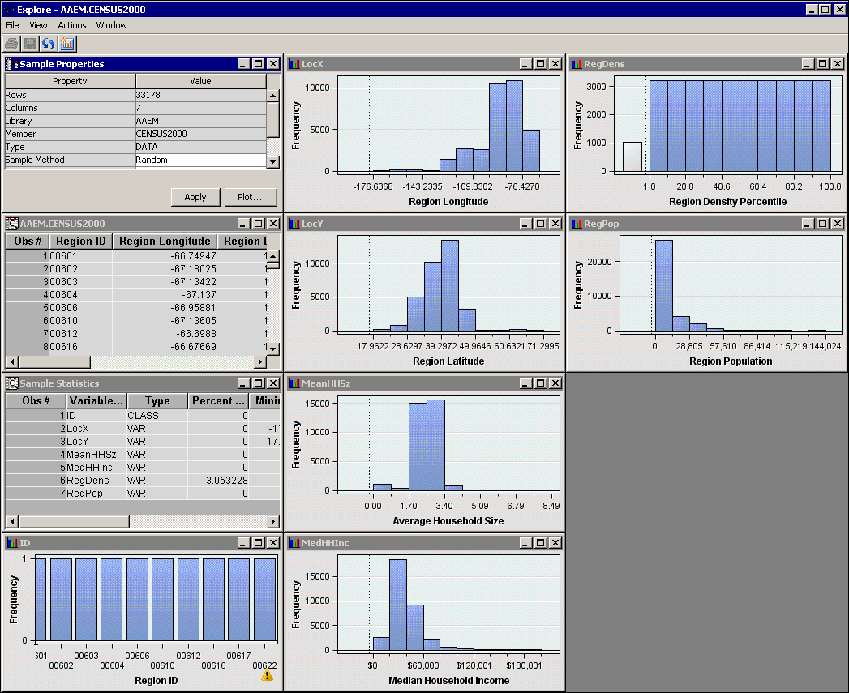
- Maximize the MeanHHSz histogram by double-clicking its title bar. The histogram now fills the Explore window.
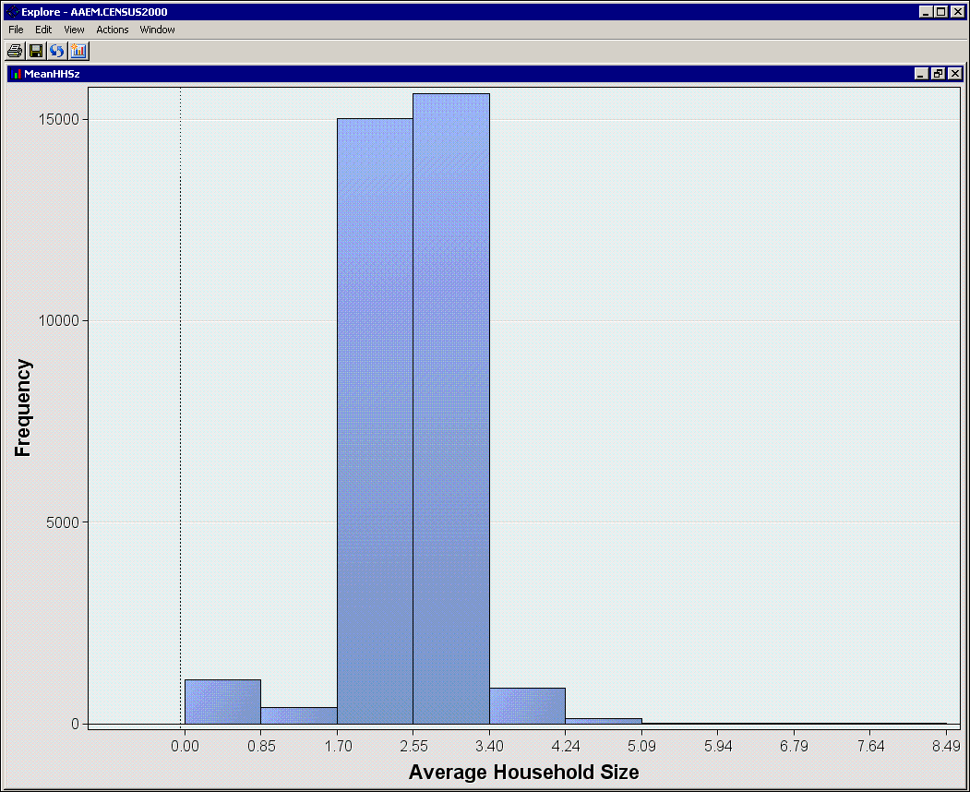
As before, increasing the number of histogram bins from the default of 10 increases your understanding of the data.
- Right-click in the histogram window and select Graph Properties from the shortcut menu.
The Properties - Histogram dialog box appears.
You can use the Properties - Histogram dialog box to change the appearance of the corresponding histogram. Type 100 in the Number of X Bins field and select OK.
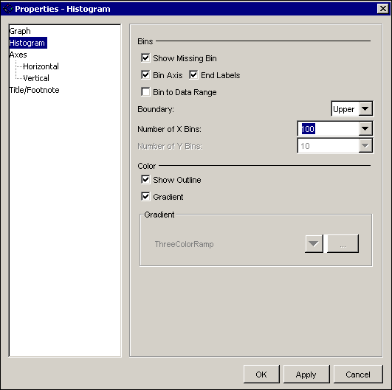
The histogram is updated to show 100 bins.
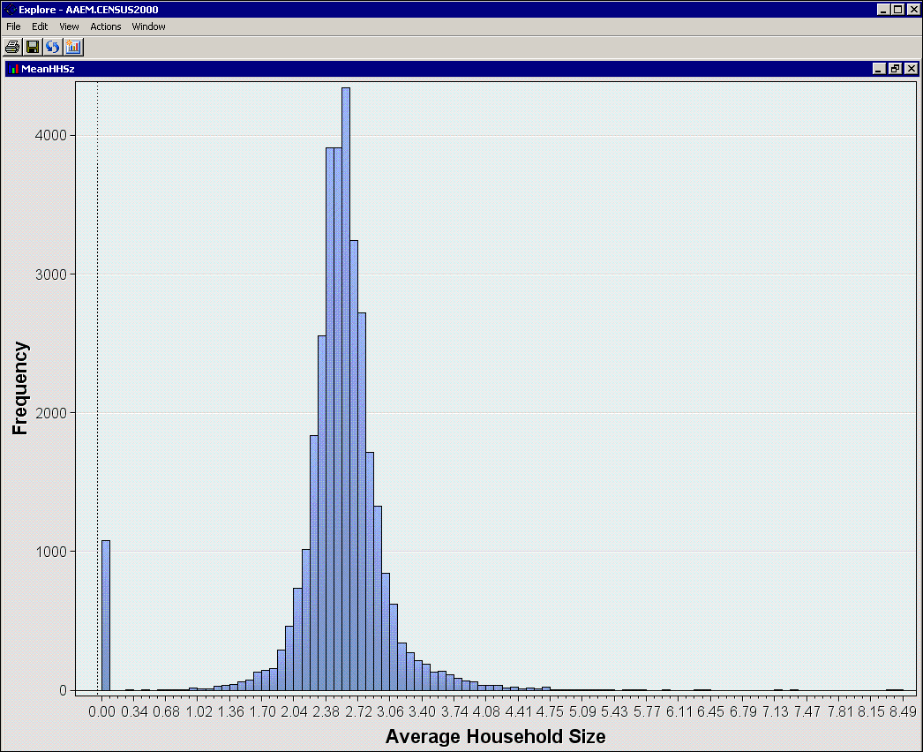
There is a curious spike in the histogram at (or near) zero. A zero household size does not make sense in the context of census data.
- Select the bar near zero in the histogram.
- Restore the size of the window by double-clicking the title bar of the MeanHHSz window.
The window returns to its original size.
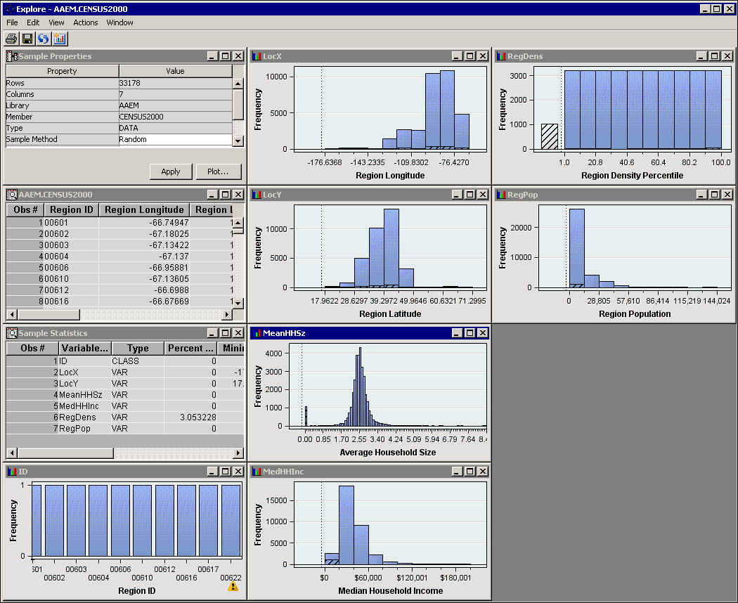
The zero average household size seems to be evenly distributed across the longitude, latitude, and density percentile variables. It seems concentrated on low incomes and populations, and also makes up the majority of the missing observations in the distribution of Region Density. It is worthwhile
to look at the individual records of the explore sample.
- Maximize the CENSUS2000 data table.
- Scroll in the data table until you see the first selected row.
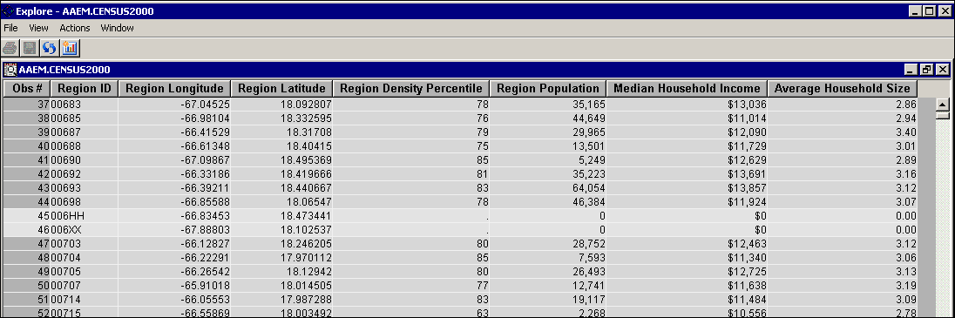
Records 45 and 46 (among others) have the zero Average Household Size characteristic. Other fields in these records also have unusual values.
- Select the Average Household Size column heading twice to sort the table by ascending values
in this field. Cases of interest are collected at the top of the data table.
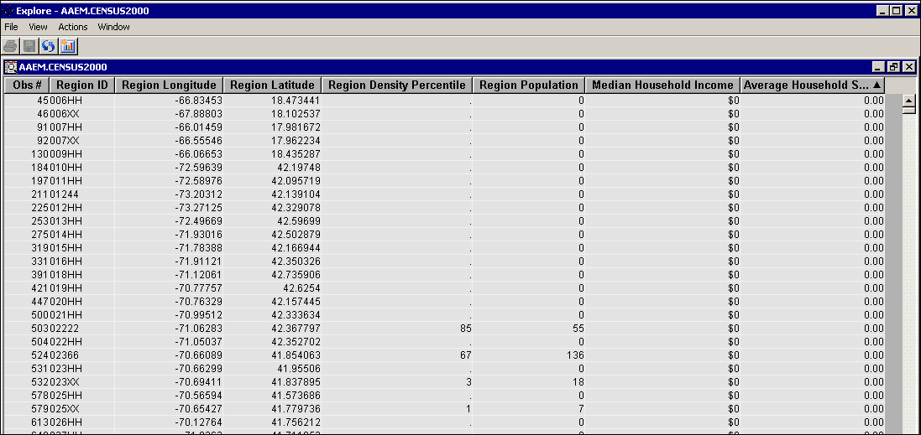
Most of the cases with zero Average Household Size have zero or missing on the remaining non-geographic attributes. There are some exceptions, but it could be argued that cases such as this are not of interest for analyzing household demographics. The next part of this demonstration shows how to remove cases such as this from the subsequent analyses.
- Close the Explore and Variables windows.

Case Filtering
The SAS Enterprise Miner Filter tool enables you to remove unwanted records from an analysis.
Use these steps to build a diagram to read a data source and to filter records.
- Drag the CENSUS2000 data source to the Segmentation Analysis workspace window.
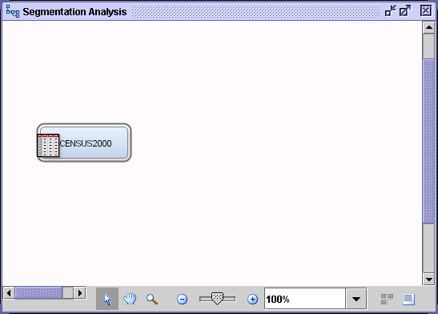
- Select the Sample tab to access the Sample tool group.
- Drag the Filter tool (fourth from the left) from the tools pallet into the Segmentation Analysis workspace window and connect it to the CENSUS2000 data source.
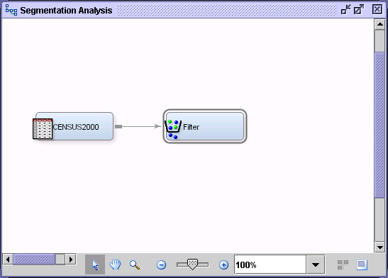
- Select the Filter node and examine the Properties panel.
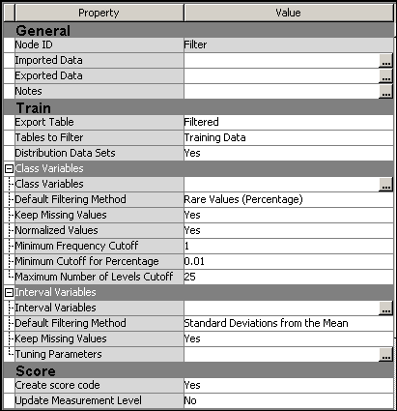
Based on the values of the Properties panel, the node will, by default, filter cases in rare levels in any class input variable and cases exceeding three standard deviations from the mean on any interval input variable.
Because the CENSUS2000 data source only contains interval inputs, only the Interval Variables criterion is considered.
- Change the Default Filtering Method property to User-Specified Limits.
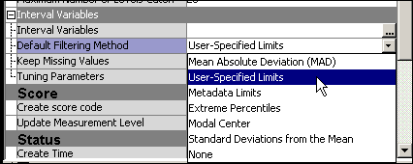
- Select the Interval Variables ellipsis (…). The Interactive Interval Filter window appears.
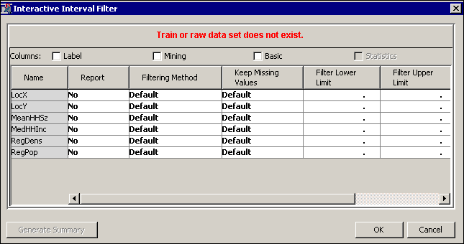
You are warned at the top of the dialog box that the Train or raw data set does not exist.
This indicates that you are restricted from the interactive filtering elements of the node, which
are available after a node is run. You can, nevertheless, enter filtering information.
- Type 0.1 as the Filter Lower Limit value for the input variable MeanHHSz.
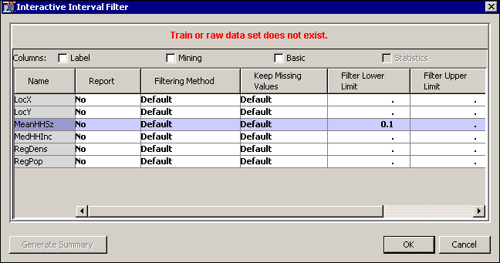
- Select OK to close the Interactive Interval Filter dialog box. You are returned to the SAS Enterprise Miner interface window.
All cases with an average household size less than 0.1 will be filtered from subsequent analysis steps.
- Run the Filter node and view the results. The Results window appears.
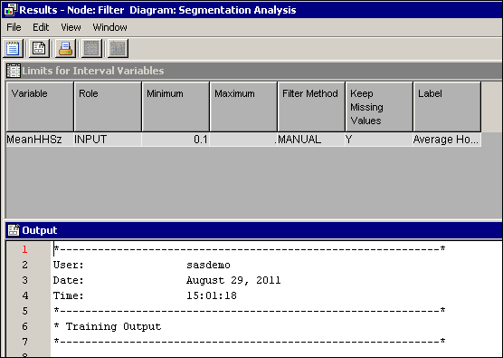
- Go to line 38 in the Output window.
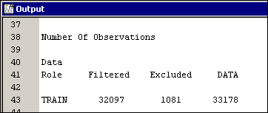
The Filter node removed 1081 cases with a household size of zero.
- Close the Results window. The CENSUS2000 data is ready for segmentation.

Setting Cluster Tool Options

The Cluster tool performs k-means cluster analyses, a widely used method for cluster and segmentation analysis. This demonstration shows you how to use the tool to segment the cases in the CENSUS2000 data set.
- Select the Explore tab.
- Locate and drag a Cluster tool into the diagram workspace.
- Connect the Filter node to the Cluster node.
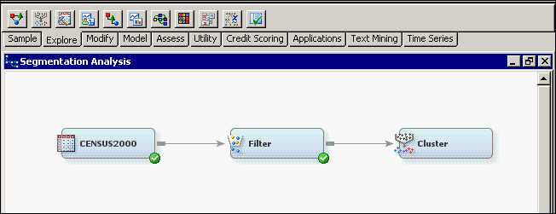
To create meaningful segments, you need to set the Cluster node to do the following:
- ignore irrelevant inputs
- standardize the inputs to have a similar range
- Select the Variables property for the Cluster node. The Variables window appears.
- Select Use ⇨ No for LocX, LocY, and RegPop.
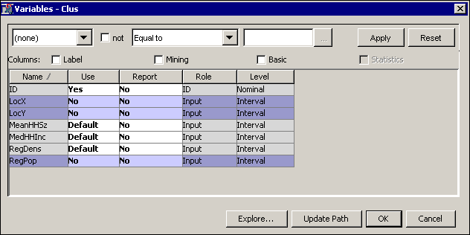
The Cluster node creates segments using the inputs MedHHInc, MeanHHSz, and RegDens.
Segments are created based on the (Euclidean) distance between each case in the space of selected inputs. If you want to use all the inputs to create clusters, these inputs should have similar measurement scales. Calculating distances using standardized distance measurements (subtracting the mean and dividing by the standard deviation of the input values) is one way to ensure this. You can standardize the input measurements using the Transform Variables node. However, it is easier to use the built-in property in the Cluster node.
- Select the inputs MedHHInc, MeanHHSz, and RegDens and select Explore. The Explore window appears.
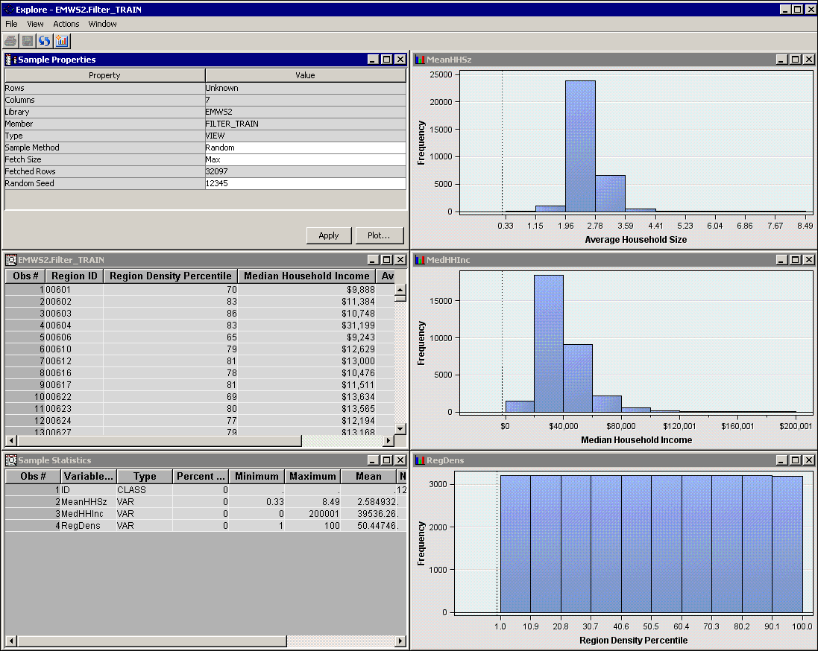
The inputs that are selected for use in the cluster are on three entirely different measurement scales.
They need to be standardized if you want a meaningful clustering.
- Close the Explore window.
- Select OK to close the Variables window.
- Note the default setting for Internal Standardization: Internal Standardization ⇨ Standardization. No change is required because standardization will be performed on input variables. Distances between points are calculated based on standardized measurements.
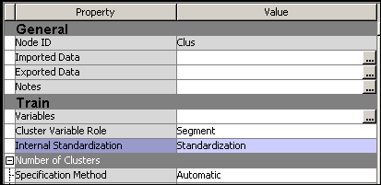
 Another way to standardize an input is by subtracting the input’s minimum value and dividing by the input’s range. This is called range standardization. Range standardization rescales the distribution of each input to the unit interval, [0,1].
The Cluster node is ready to run.
Creating Clusters with the Cluster Tool

By default, the Cluster tool attempts to automatically determine the number of clusters in the data.
A three-step process is used.
Step 1 A large number of cluster seeds are chosen (50 by default) and placed in the input space. Cases
in the training data are assigned to the closest seed, and an initial clustering of the data is completed. The means of the input variables in each of these preliminary clusters are substituted for the original training data cases in the second step of the process.
Step 2 A hierarchical clustering algorithm (Ward’s method) is used to sequentially consolidate the clusters that were formed in the first step. At each step of the consolidation, a statistic named the cubic clustering criterion (CCC) (Sarle 1983) is calculated. Then, the smallest number of clusters that meets both of the following criteria is selected:
- The number of clusters must be greater than or equal to the number that is specified as the minimum value in the Selection Criterion properties.
- The number of clusters must have cubic clustering criterion statistic values that are greater than the CCC threshold that is specified in the Selection Criterion properties.
Step 3 The number of clusters determined by the second step provides the value for k in a k-means clustering of the original training data cases.
- Run the Cluster node and select Results. The Results - Cluster window appears.
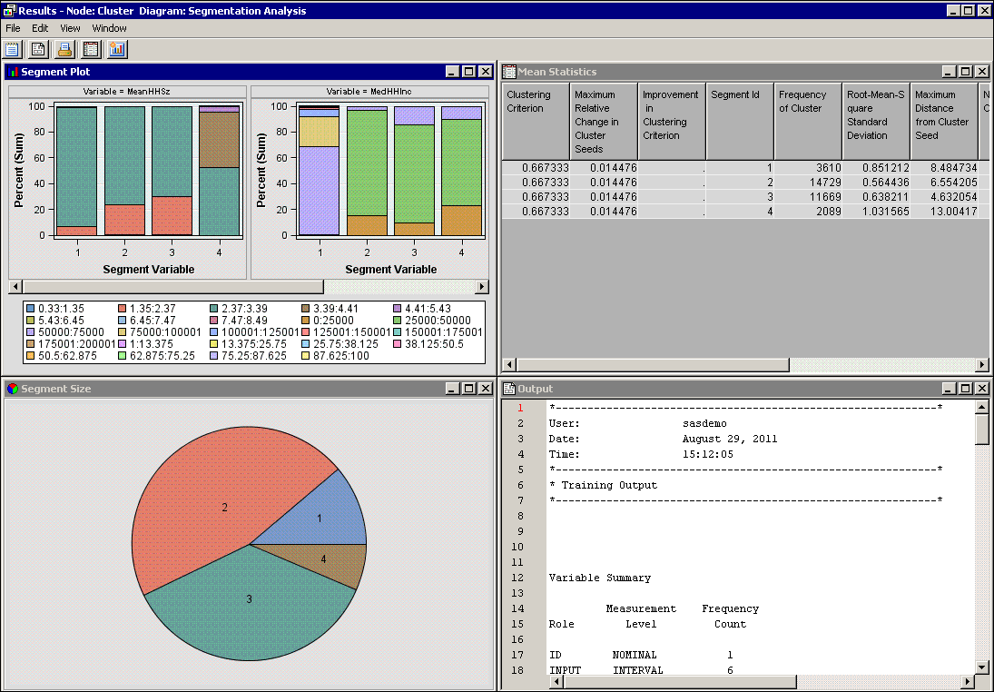
The Results - Cluster window contains four embedded windows.
- The Segment Plot window attempts to show the distribution of each input variable by cluster.
- The Mean Statistics window lists various descriptive statistics by cluster.
- The Segment Size window shows a pie chart describing the size of each cluster formed.
- The Output window shows the output of various SAS procedures run by the Cluster node.
Apparently, the Cluster node found four clusters in the CENSUS2000 data. Because the number of clusters is based on the cubic clustering criterion, it might be interesting to examine the values of this statistic for various cluster counts.
- Select View ⇨ Summary Statistics ⇨ CCC Plot. The CCC Plot window appears.
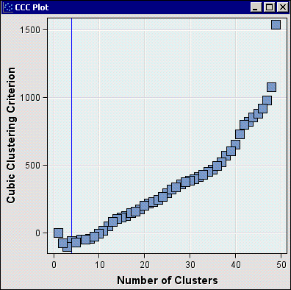
In theory, the number of clusters in a data set is revealed by the peak of the CCC versus Number of Clusters plot. However, when no distinct concentrations of data exist, the utility of the CCC statistic is somewhat suspect. SAS Enterprise Miner attempts to establish reasonable defaults for its analysis tools. The appropriateness of these defaults, however, strongly depends on the analysis objective and the nature of the data.

Specifying the Segment Count

You might want to increase the number of clusters created by the Cluster node. You can do this
by changing the CCC cutoff property or by specifying the desired number of clusters.
- In the Properties panel for the Cluster node, select Specification Method ⇨ User Specify.
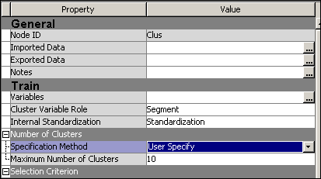
The User Specify setting creates a number of segments indicated by the Maximum Number
of Clusters property (in this case, 10).
- Run the Cluster node and select Results. The Results - Node: Cluster Diagram window appears, and shows a total of 10 generated segments.
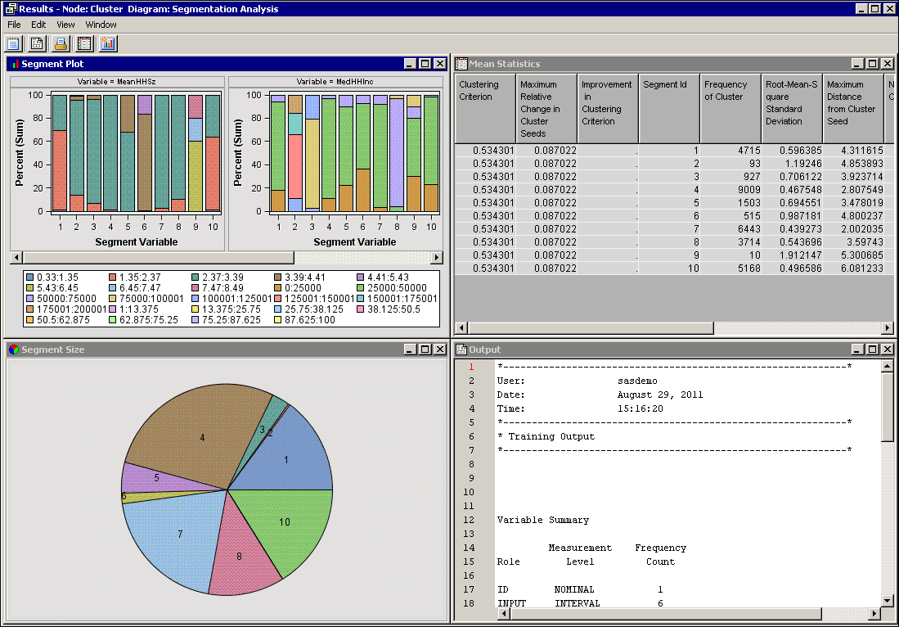
As seen in the Mean Statistics window, segment frequency counts vary from 10 cases to more than 9,000 cases.
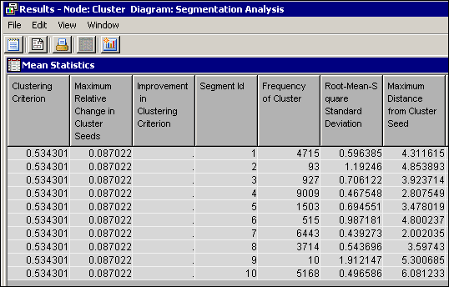
Exploring Segments

While the Results window shows a variety of data summarizing the analysis, it is difficult to understand the composition of the generated clusters. If the number of cluster inputs is small, the Graph wizard can aid in interpreting the cluster analysis.
- Close the Results - Cluster window.
- Select Exported Data from the Properties panel for the Cluster node. The Exported Data - Cluster window appears.
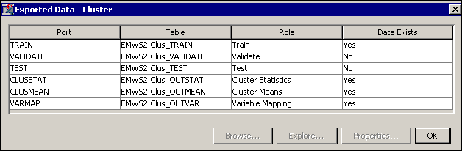
This window shows the data sets that are generated and exported by the Cluster node.
- Select the Train data set and select Explore. The Explore window appears.
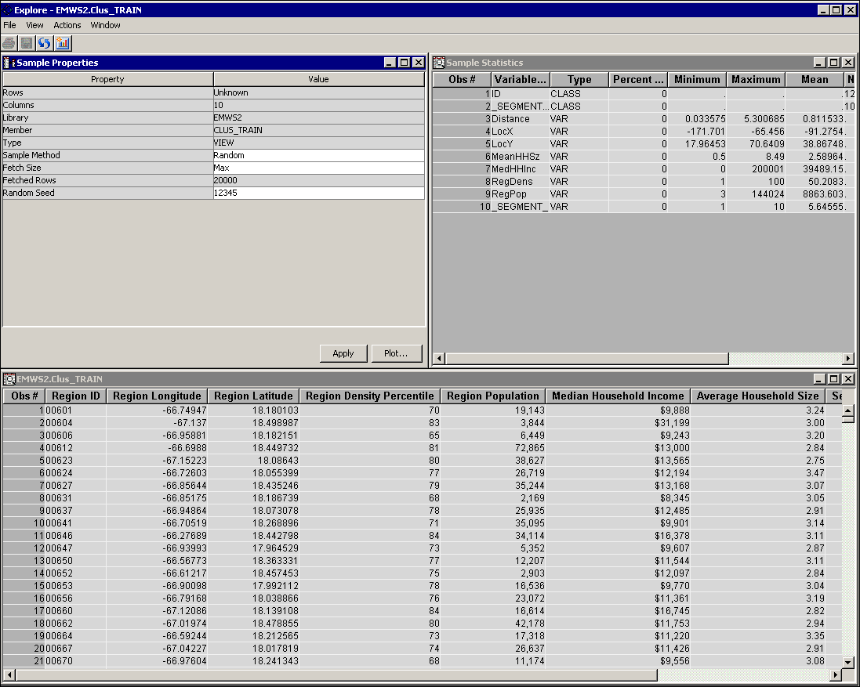
You can use the Graph wizard to generate plots of the CENSUS2000 data.
- Select Actions ⇨ Plot. The Select a Chart Type window appears. Select Scatter to create a
scatter plot.
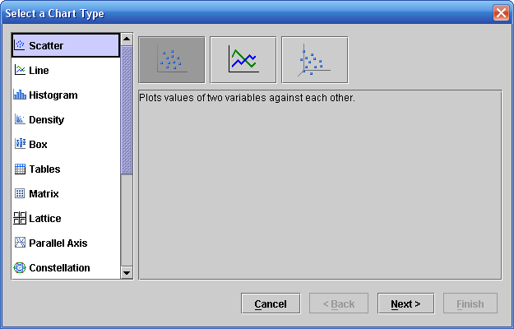
- Select Next. The Graph wizard proceeds to the next step, Select Chart Roles.
- Select roles of X, Y, for LocX, LocY. Select Color as the role for _SEGMENT_. And select Tip as the role forMeanHHSz, MedHHInc, and RegDens.. Allow multiple role assignments by selecting the box at the bottom of the table.
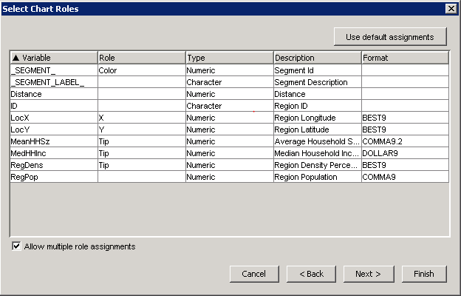
- Select Finish.
The Explore window displays a plot of the CENSUS2000 data.
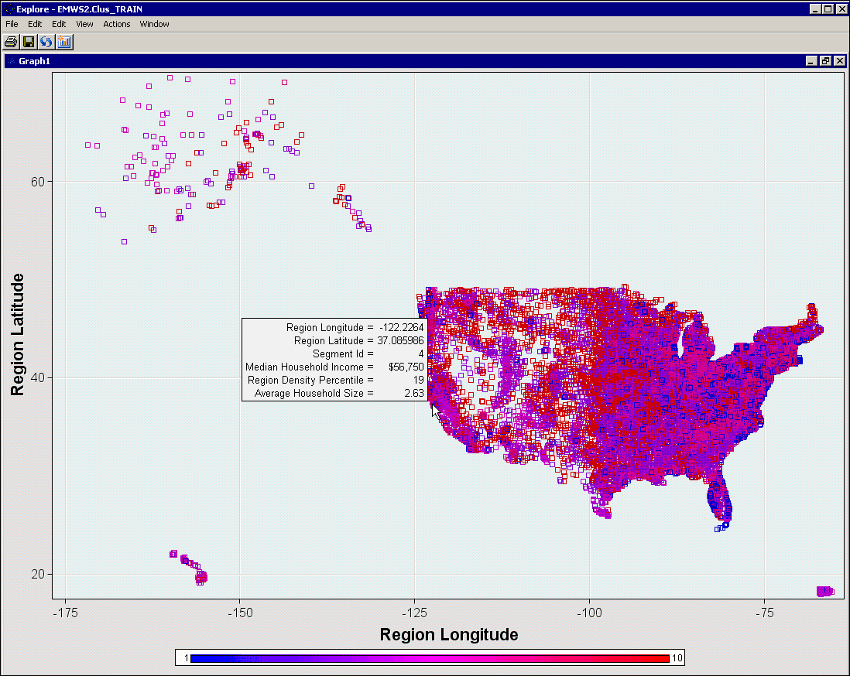
- Display the tool tips by holding the cursor over a point in the plot.
Each square in the plot represents a unique postal code. The squares are color-coded by cluster segment.
Right-click in the plot to modify graph properties such as marker size and colors.
To further aid interpretability, add a distribution plot of the segment number.
- Select Action ⇨ Plot…. The Select a Chart Type window appears.
- Select Bar.
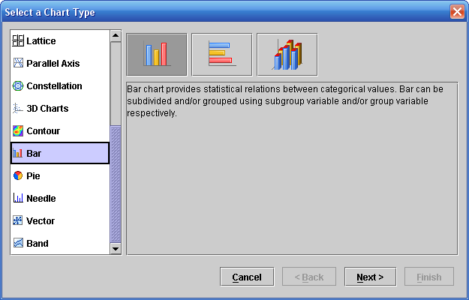
- Select Next.
- Select Role ⇨ Category for the variable _SEGMENT_.
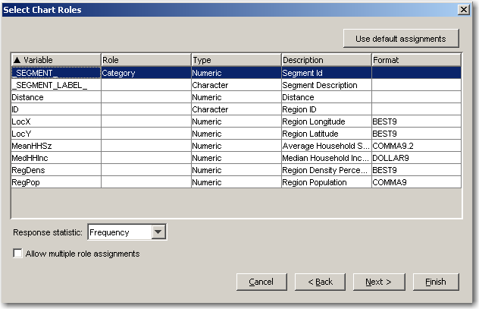
- Select Finish.
A histogram of _SEGMENT_ is displayed.
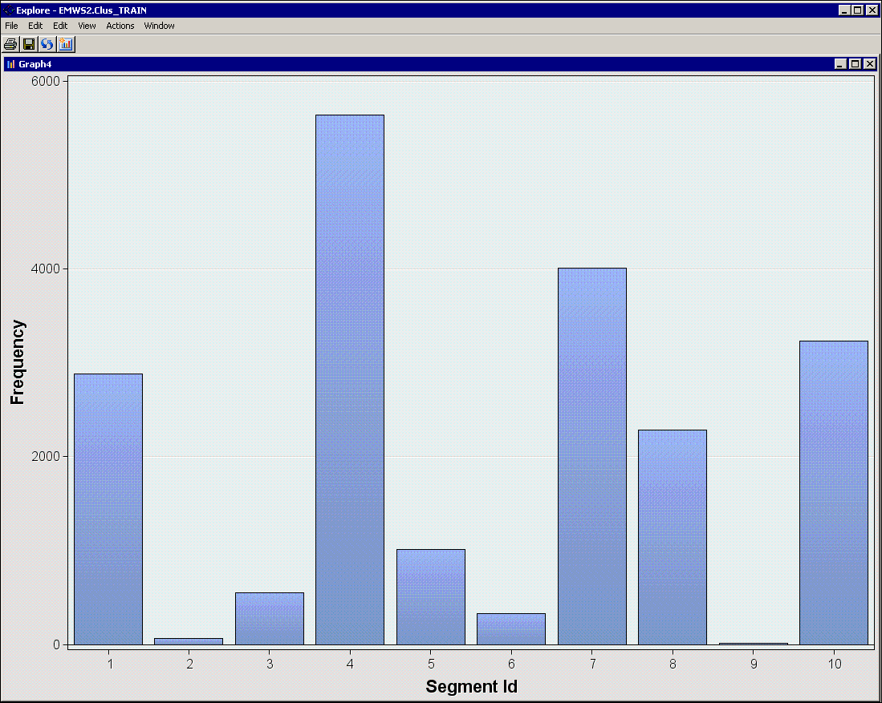
By itself, this plot is of limited use. However, when the plot is combined with the plot using latitude and longitude, you can easily interpret the generated segments in a two-dimensional plot of the USA.
- Select Window ⇨ Tile to show both graphs after deleting the other tables from the Explore window.
Drag the cursor over a segment of the plot of the USA and notice that the cluster segments in this area are highlighted in the histogram.
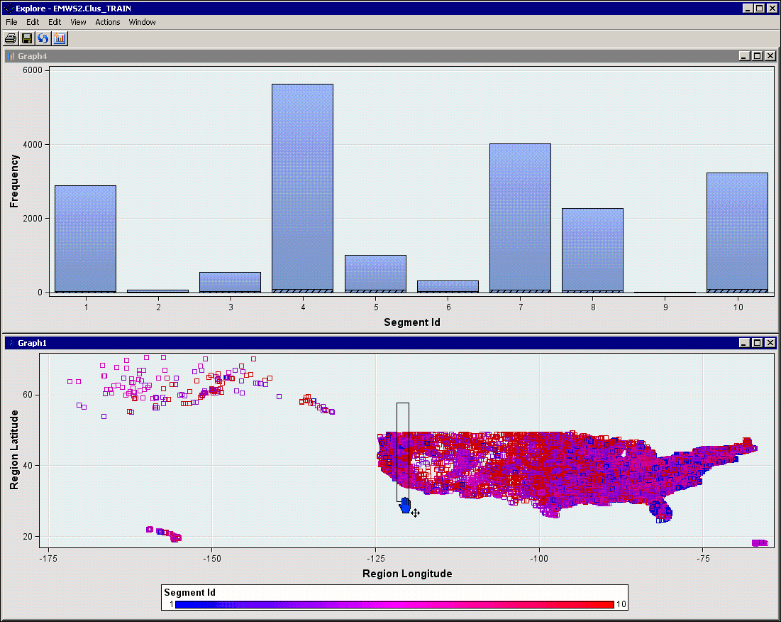
- Move the box to the right and notice that the selected proportions in the histogram change as you move the box.
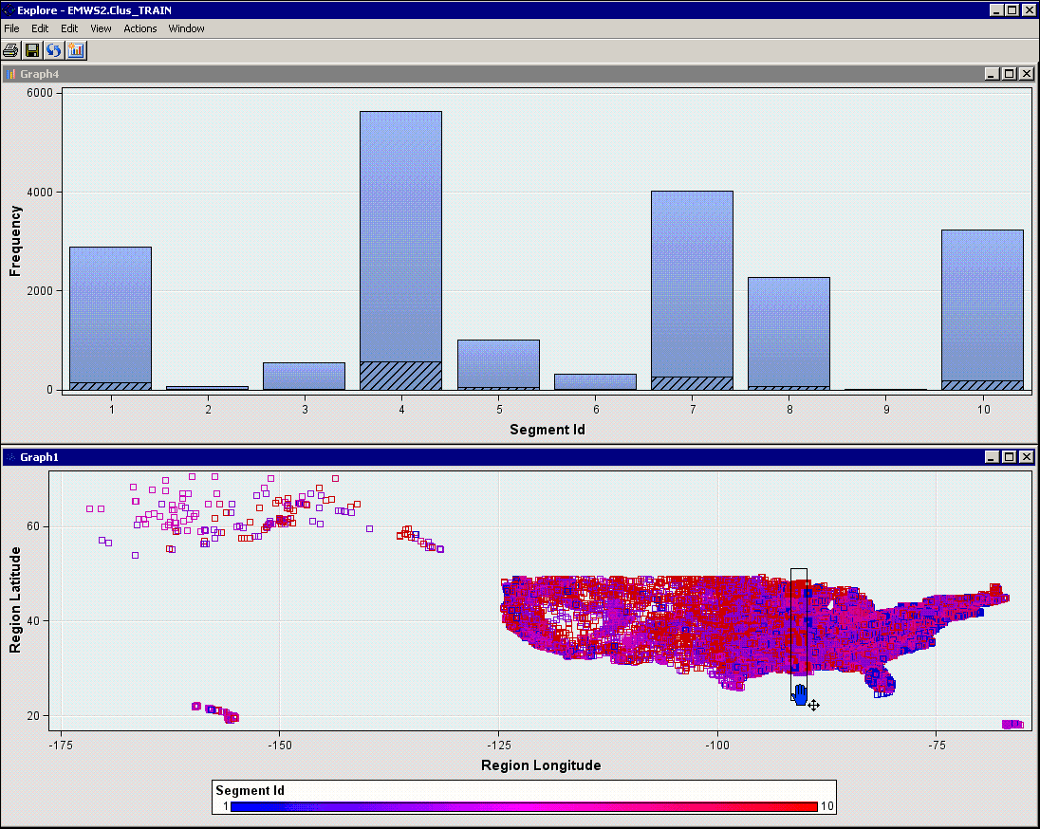
- Experiment with creating other types of graphs with this data in the Explore window. For example, consider a three-dimensional scatter plot, using MeanHHSz, MedHHInc, and RegDens on each axis with the variable _SEGMENT_ assigned the role Color.
- Close the Explore, Exported Data, and Results windows.

Profiling Segments

You can gain a great deal of insight by creating plots as in the previous demonstration. Unfortunately,
if more than three variables are used to generate the segments, the interpretation of such plots becomes difficult.
Fortunately, there is another useful tool in SAS Enterprise Miner for interpreting the composition of clusters: the Segment Profile tool. This tool enables you to compare the distribution of a variable in an individual segment to the distribution of the variable overall. As a bonus, the variables are sorted by how well they characterize the segment.
- Drag a Segment Profile tool from the Assess tool palette into the diagram workspace.
- Connect the Cluster node to the Segment Profile node.
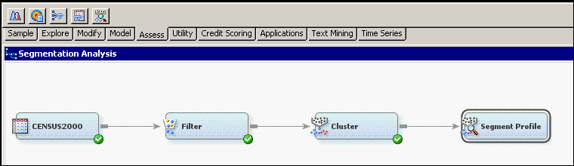
To best describe the segments, you should pick a reasonable subset of the available input variables.
- Select the Variables property for the Segment Profile node.
- Select Use ⇨ No for ID, LocX, LocY, and RegPop.
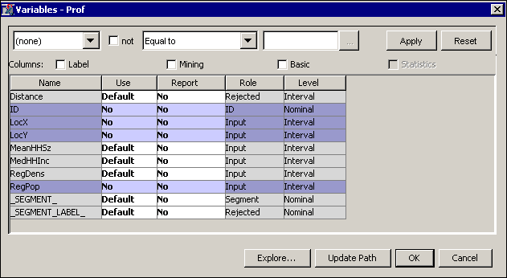
- Select OK to close the Variables dialog box.
- Run the Segment Profile node and select Results. The Results - Node: Segment Profile Diagram window appears.
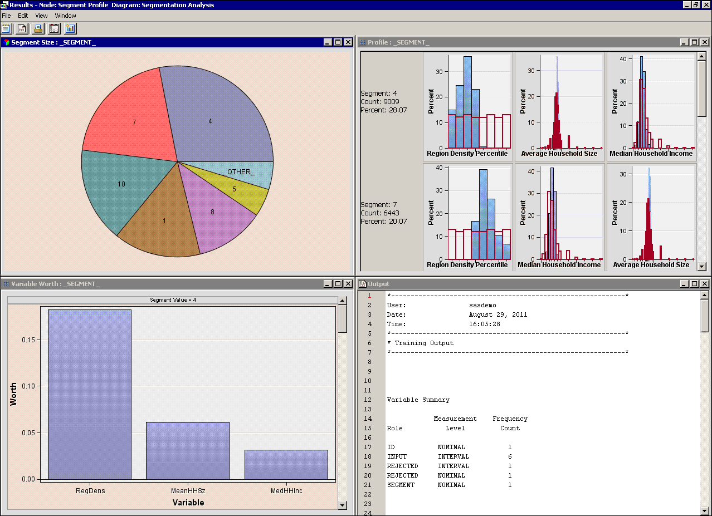
- Maximize the Profile window.
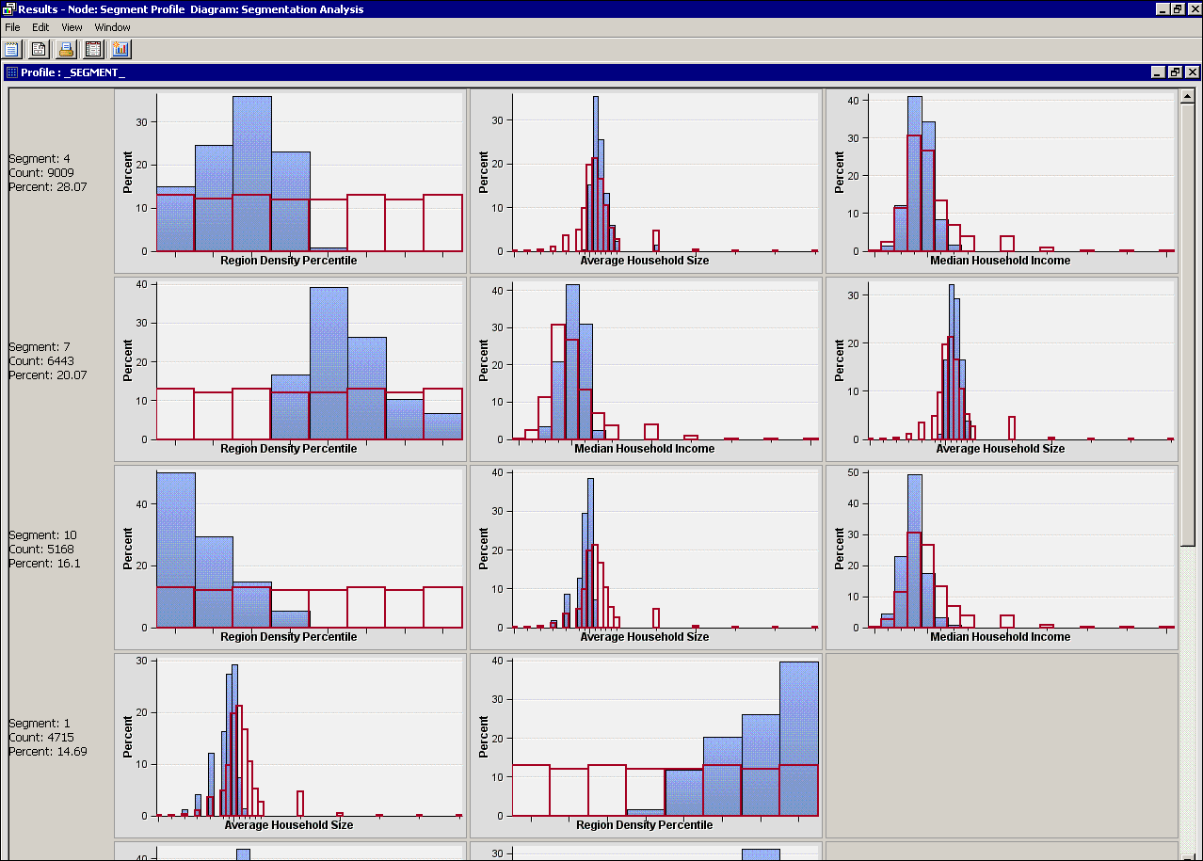
Features of each segment become apparent. For example, segment 4, when compared to the overall distributions, has a lower Region Density Percentile, more central Median Household Income, and slightly higher Average Household Size.
- Maximize the Variable Worth: _SEGMENT_ window.
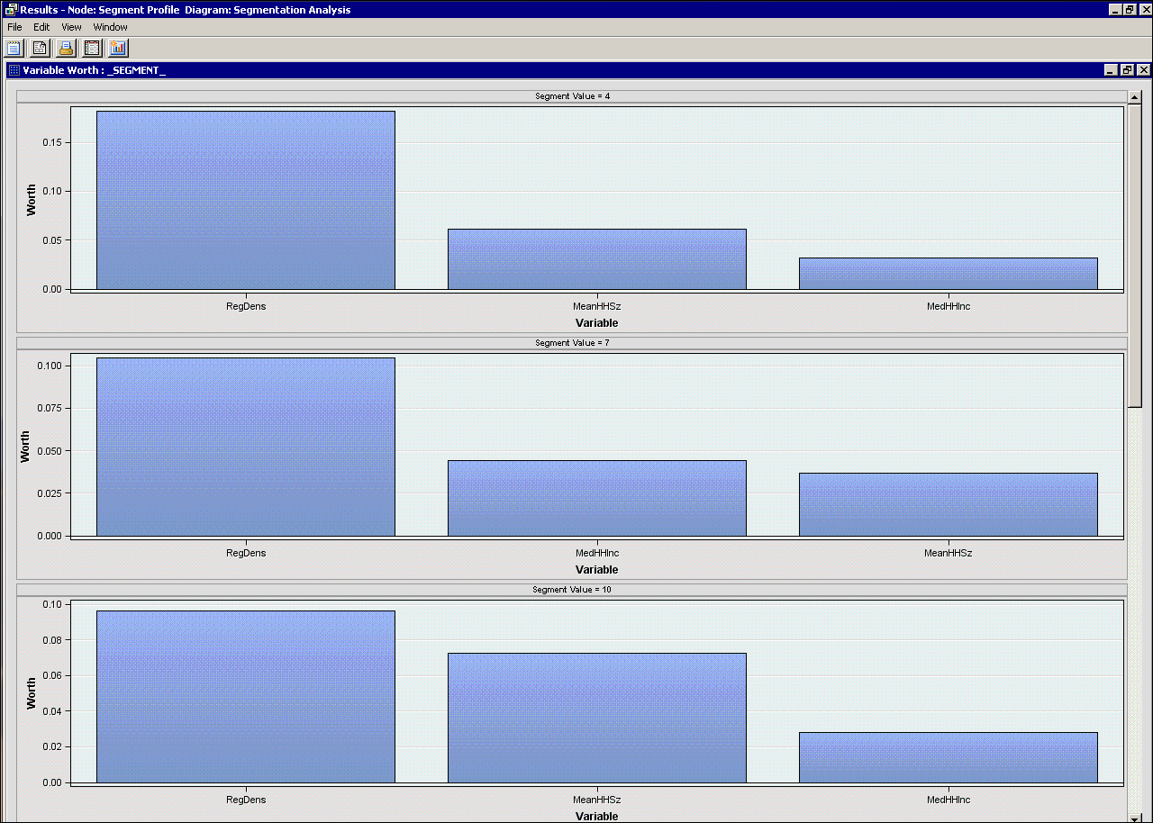
The window shows the relative worth of each variable in characterizing each segment. For example, segment 4 is largely characterized by the RegDens input, but the other two inputs also play a role.
Again, similar analyses can be used to describe the other segments. The advantage of the Segment Profile window (compared to direct viewing of the segmentation) is that the descriptions can be more than three-dimensional.

